Berry Module 2 Homework

Initial write up:

Sub stock_analysis Test()

'Set dimentsions

Dim total As Double

Dim i As Long

Dim j As Integer

Dim change As Double

Dim percentagechange As Double

Dim dailychange As Double

Dim averagechange As Double

Dim start As Long

Dim rowcount As Long

' Set title row

Range("I1").Value = "Ticker"

Range("J1").Value = "Quarterly Change"

Range("K1").Value = "Percent Change"

Range("L1").Value = "Total Stock Volume"

Range("P1").Value = "Ticker"

Range("Q1").Value = "Value"

Range("Q2").Value = "Greatest % Increase"

Range("Q3").Value = "Greatest % Decrease"

Range("Q4").Value = "Greatest Total Volume"

' Set initial values

j = 0

total -0

change = 2

start = 2

' get the row number of the last row with data

rowcount = Cells(Row.Count, "A").End(xlUp).Row

For i = 2 To rowcount

' If ticker changes then print results, use Range!

If Cells(i + 1, 1).Value <> Cells(i, 1).Value Then

' Do stuff

' reset variables for the new stock ticker

Else

' row should also be fine

total = total + Cells(i + 7)

End If

' take the max and min and place them in a seperate part in the worksheet

' final ticker symbol for total, greatest % of increase and decrease, and average

End Sub

Second write up:

Sub stock_analysis ()

' stocks are pre-sorted

' LOOP by rows

' Big idea: create a leaderboard

' IF next stock is different, that means we have finished our group

' ELSE, then keep summing the volume

' variables

Dim stock As String

Dim next_stock As String

Dim volume As LongLong

Dim volume_total As LongLong

Dim i As Long

Dim leaderboard_row As Long

Dim lastRow As Integer

' new variables

Dim open_price As Double

Dim closing_price As Double

Dim change As Double

Dim pct_change As Double

' Reset per stock

volume_total = 0

open_price = Cells(2, 3).Value

leaderboard_row = 2

lastRow = Sheets("A").Cells(Rows.Count, 1).End(xlUp).Row

For i = 2 To lastRow

' extract values from workbook

stock = Cells(i, 1).Value

volume = Cells(i, 7).Value

next_stock = Cells(i + 1, 1).Value

' if statement

If (stock <> next_stock) Then

' add total

volume_total = volume_total + volume

' Change logic

closing_price = Cells(i, 6).Value

change = closing_price - open_price

pct_change = change / open_price * 100

' write to leaderboard

Cells(leaderboard_row, 12).Value = volume_total

Cells(leaderboard_row, 11).Value = pct_change

Cells(leaderboard_row, 10).Value = change

Cells(leaderboard_row, 9).Value = stock

' Conditional Formatting

If (change > 0) Then

Cells(leaderboard_row, 10).Interior.ColorIndex = 4

ElseIf (change < 0) Then

Cells(leaderboard_row, 10).Interior.ColorIndex = 3

Else

' Do Nothing (default White)

End If

' reset total

volume_total = 0

leaderboard_row = leaderboard_row + 1

open_price = Cells(i + 1, 3).Value ' the open price of the NEXT stock

Else

' add total

volume_total = volume_total + volume

End If

Next i

End Sub

Third write up:

Sub stock_analysis ()

' stocks are pre-sorted

' LOOP by rows

' Big idea: create a leaderboard

' IF next stock is different, that means we have finished our group

' ELSE, then keep summing the volume

' variables

Dim stock As String

Dim next_stock As String

Dim volume As LongLong

Dim volume_total As LongLong

Dim i As Long

Dim leaderboard_row As Long

Dim lastRow As Integer

' new variables

Dim open_price As Double

Dim closing_price As Double

Dim change As Double

Dim pct_change As Double

' Reset per stock

volume_total = 0

open_price = Cells(2, 3).Value

leaderboard_row = 2

lastRow = Sheets("A").Cells(Rows.Count, 1).End(xlUp).Row

For i = 2 To lastRow

' extract values from workbook

stock = Cells(i, 1).Value

volume = Cells(i, 7).Value

next_stock = Cells(i + 1, 1).Value

' if statement

If (stock <> next_stock) Then

' add total

volume_total = volume_total + volume

' Change logic

closing_price = Cells(i, 6).Value

change = closing_price - open_price

pct_change = change / open_price * 100

' write to leaderboard

Cells(leaderboard_row, 12).Value = volume_total

Cells(leaderboard_row, 11).Value = pct_change

Cells(leaderboard_row, 10).Value = change

Cells(leaderboard_row, 9).Value = stock

' Conditional Formatting

If (change > 0) Then

Cells(leaderboard_row, 10).Interior.ColorIndex = 4

ElseIf (change < 0) Then

Cells(leaderboard_row, 10).Interior.ColorIndex = 3

Else

' Do Nothing (default White)

End If

' reset total

volume_total = 0

leaderboard_row = leaderboard_row + 1

open_price = Cells(i + 1, 3).Value ' the open price of the NEXT stock (tricky gotcha)

Else

' add total

volume_total = volume_total + volume

End If

Next i

' Second Loop for Second Leaderboard

Dim max_price As Double

Dim min_price As Double

Dim max_volume As LongLong

Dim max_price_stock As String

Dim min_price_stock As String

Dim max_volume_stock As String

Dim j As Integer

' init to first row of the first leaderboard for comparison

max_price = Cells(2, 11).Value

min_price = Cells(2, 11).Value

max_volume = Cells(2, 12).Value

max_price_stock = Cells(2, 9).Value

min_price_stock = Cells(2, 9).Value

max_volume_stock = Cells(2, 9).Value

For j = 2 To leaderboard_row

' Compare current row to the inits (first row)

If (Cells(j, 11).Value > max_price) Then

' We have a new Max Percent Change!

max_price = Cells(j, 11).Value

max_price_stock = Cells(j, 9).Value

End If

If (Cells(j, 11).Value < min_price) Then

' We have a new Min Percent Change!

min_price = Cells(j, 11).Value

min_price_stock = Cells(j, 9).Value

End If

If (Cells(j, 12).Value > max_volume) Then

' We have a new Max Volume!

max_volume = Cells(j, 12).Value

max_volume_stock = Cells(j, 9).Value

End If

Next j

' Write out to Excel Workbook

Range("O2").Value = max_price_stock

Range("O3").Value = min_price_stock

Range("O4").Value = max_volume_stock

Range("P2").Value = max_price

Range("P3").Value = min_price

Range("P4").Value = max_volume

End Sub

Fourth write up:

Sub stock_analysis ()

' stocks are pre-sorted

' LOOP by rows

' Big idea: create a leaderboard

' IF next stock is different, that means we have finished our group

' ELSE, then keep summing the volume

' variables

Dim ws As Worksheet

Dim stock As String

Dim next_stock As String

Dim volume As LongLong

Dim volume_total As LongLong

Dim i As Long

Dim leaderboard_row As Long

Dim lastRow As Integer

' new variables

Dim open_price As Double

Dim closing_price As Double

Dim change As Double

Dim pct_change As Double

For Each ws In ThisWorkbook.Worksheets

' Set Column Headers

ws.Range("I1").Value = "Ticker"

ws.Range("J1").Value = "Quarterly Change"

ws.Range("K1").Value = "Percent Change"

ws.Range("L1").Value = "Total Stock Volume"

ws.Range("O1").Value = "Ticker"

ws.Range("P1").Value = "Value"

ws.Range("N2").Value = "Greatest % Increase"

ws.Range("N3").Value = "Greatest % Decrease"

ws.Range("N4").Value = "Greatest Total Volume"

' Reset per stock

volume_total = 0

open_price = ws.Cells(2, 3).Value

leaderboard_row = 2

lastRow = ws.Cells(Rows.Count, 1).End(xlUp).Row

For i = 2 To lastRow

' extract values from workbook

stock = ws.Cells(i, 1).Value

volume = ws.Cells(i, 7).Value

next_stock = ws.Cells(i + 1, 1).Value

' if statement

If (stock <> next_stock) Then

' add total

volume_total = volume_total + volume

' Change logic

closing_price = ws.Cells(i, 6).Value

change = closing_price - open_price

pct_change = change / open_price

' write to leaderboard

ws.Cells(leaderboard_row, 12).Value = volume_total

ws.Cells(leaderboard_row, 11).Value = FormatPercent(pct_change)

ws.Cells(leaderboard_row, 10).Value = change

ws.Cells(leaderboard_row, 9).Value = stock

' Conditional Formatting

If (change > 0) Then

ws.Cells(leaderboard_row, 10).Interior.ColorIndex = 4

ElseIf (change < 0) Then

ws.Cells(leaderboard_row, 10).Interior.ColorIndex = 3

Else

' Do Nothing (default White)

End If

' reset total

volume_total = 0

leaderboard_row = leaderboard_row + 1

open_price = ws.Cells(i + 1, 3).Value ' the open price of the NEXT stock (tricky gotcha)

Else

' add total

volume_total = volume_total + volume

End If

Next i

' Second Loop for Second Leaderboard

Dim max_price As Double

Dim min_price As Double

Dim max_volume As LongLong

Dim max_price_stock As String

Dim min_price_stock As String

Dim max_volume_stock As String

Dim j As Integer

' init to first row of the first leaderboard for comparison

max_price = ws.Cells(2, 11).Value

min_price = ws.Cells(2, 11).Value

max_volume = ws.Cells(2, 12).Value

max_price_stock = ws.Cells(2, 9).Value

min_price_stock = ws.Cells(2, 9).Value

max_volume_stock = ws.Cells(2, 9).Value

For j = 2 To leaderboard_row

' Compare current row to the inits (first row)

If (ws.Cells(j, 11).Value > max_price) Then

' We have a new Max Percent Change!

max_price = ws.Cells(j, 11).Value

max_price_stock = ws.Cells(j, 9).Value

End If

If (Cells(j, 11).Value < min_price) Then

' We have a new Min Percent Change!

min_price = ws.Cells(j, 11).Value

min_price_stock = ws.Cells(j, 9).Value

End If

If (Cells(j, 12).Value > max_volume) Then

' We have a new Max Volume!

max_volume = ws.Cells(j, 12).Value

max_volume_stock = ws.Cells(j, 9).Value

End If

Next j

' Write out to Excel Workbook

ws.Range("O2").Value = max_price_stock

ws.Range("O3").Value = min_price_stock

ws.Range("O4").Value = max_volume_stock

ws.Range("P2").Value = max_price

ws.Range("P3").Value = min_price

ws.Range("P4").Value = max_volume

Next ws

End Sub

Sub reset()

Dim ws As Worksheet

For Each ws In ThisWorkbook.Worksheets

' Delete columns I through P

ws.Range("I:P").Delete

Next ws

End Sub

Final write up:

Sub stock_analysis()

' stocks are pre-sorted

' LOOP by rows

' Big idea: create a leaderboard

' IF next stock is different, that means we have finished our group

' ELSE, then keep summing the volume

' variables

Dim ws As Worksheet

Dim stock As String

Dim next_stock As String

Dim volume As LongLong

Dim volume_total As LongLong

Dim i As Long

Dim leaderboard_row As Long

Dim lastRow As Long

' new variables

Dim open_price As Double

Dim closing_price As Double

Dim change As Double

Dim pct_change As Double

For Each ws In ThisWorkbook.Worksheets

' Set Column Headers

ws.Range("I1").Value = "Ticker"

ws.Range("J1").Value = "Quarterly Change"

ws.Range("K1").Value = "Percent Change"

ws.Range("L1").Value = "Total Stock Volume"

ws.Range("O1").Value = "Ticker"

ws.Range("P1").Value = "Value"

ws.Range("N2").Value = "Greatest % Increase"

ws.Range("N3").Value = "Greatest % Decrease"

ws.Range("N4").Value = "Greatest Total Volume"

' Reset per stock

volume_total = 0

open_price = ws.Cells(2, 3).Value

leaderboard_row = 2

lastRow = ws.Cells(Rows.Count, 1).End(xlUp).Row

For i = 2 To lastRow

' extract values from workbook

stock = ws.Cells(i, 1).Value

volume = ws.Cells(i, 7).Value

next_stock = ws.Cells(i + 1, 1).Value

' if statement

If (stock <> next_stock) Then

' add total

volume_total = volume_total + volume

' Change logic

closing_price = ws.Cells(i, 6).Value

change = closing_price - open_price

pct_change = change / open_price

' write to leaderboard

ws.Cells(leaderboard_row, 12).Value = volume_total

ws.Cells(leaderboard_row, 11).Value = FormatPercent(pct_change)

ws.Cells(leaderboard_row, 10).Value = change

ws.Cells(leaderboard_row, 9).Value = stock

' Conditional Formatting

If (change > 0) Then

ws.Cells(leaderboard_row, 10).Interior.ColorIndex = 4

ElseIf (change < 0) Then

ws.Cells(leaderboard_row, 10).Interior.ColorIndex = 3

Else

' Do Nothing (default White)

End If

' reset total

volume_total = 0

leaderboard_row = leaderboard_row + 1

open_price = ws.Cells(i + 1, 3).Value ' the open price of the NEXT stock (tricky gotcha)

Else

' add total

volume_total = volume_total + volume

End If

Next i

' Second Loop for Second Leaderboard

Dim max_price As Double

Dim min_price As Double

Dim max_volume As LongLong

Dim max_price_stock As String

Dim min_price_stock As String

Dim max_volume_stock As String

Dim j As Integer

' init to first row of the first leaderboard for comparison

max_price = ws.Cells(2, 11).Value

min_price = ws.Cells(2, 11).Value

max_volume = ws.Cells(2, 12).Value

max_price_stock = ws.Cells(2, 9).Value

min_price_stock = ws.Cells(2, 9).Value

max_volume_stock = ws.Cells(2, 9).Value

For j = 2 To leaderboard_row

' Compare current row to the inits (first row)

If (ws.Cells(j, 11).Value > max_price) Then

' We have a new Max Percent Change!

max_price = ws.Cells(j, 11).Value

max_price_stock = ws.Cells(j, 9).Value

End If

If (Cells(j, 11).Value < min_price) Then

' We have a new Min Percent Change!

min_price = ws.Cells(j, 11).Value

min_price_stock = ws.Cells(j, 9).Value

End If

If (Cells(j, 12).Value > max_volume) Then

' We have a new Max Volume!

max_volume = ws.Cells(j, 12).Value

max_volume_stock = ws.Cells(j, 9).Value

End If

Next j

' Write out to Excel Workbook

ws.Range("O2").Value = max_price_stock

ws.Range("O3").Value = min_price_stock

ws.Range("O4").Value = max_volume_stock

ws.Range("P2").Value = FormatPercent(max_price)

ws.Range("P3").Value = FormatPercent(min_price)

ws.Range("P4").Value = max_volume

Next ws

End Sub

Sub reset()

Dim ws As Worksheet

For Each ws In ThisWorkbook.Worksheets

' Delete columns I through P

ws.Range("I:P").Delete

Next ws

End Sub

Q1 screenshot:

Q2 screenshot:

Q3 screenshot:

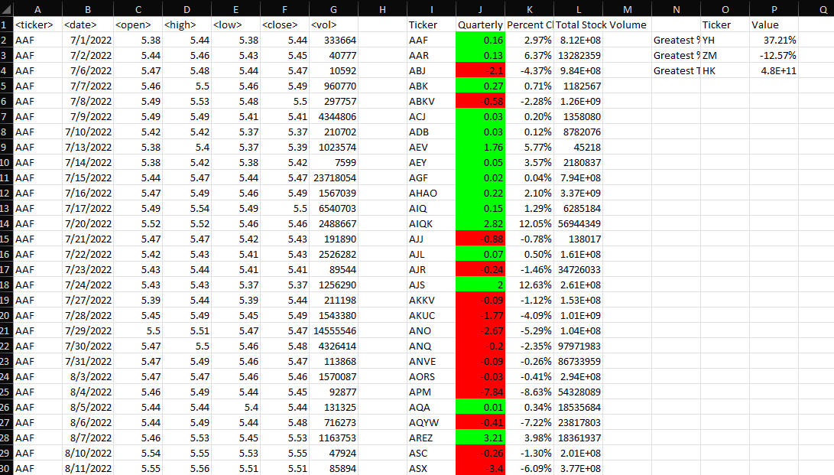

Q4 screenshot:

